**Programming Paradigms Laboratory**

**B.Tech.**



**Name : Tanishq R Porwar**

**Roll Number : 18ETCS002131**

**Department : Computer Science and Engineering**

**Faculty of Engineering & Technology**

**Ramaiah University of Applied Sciences**

|  |  |
| --- | --- |
| Faculty | Engineering & Technology |
| Programme | B. Tech. in Computer Science and Engineering |
| Year/Semester | 2nd Year / 4th Semester |
| Name of the Laboratory | Programming Paradigms Laboratory |
| Laboratory Code | 19CSL217A |

# Laboratory 8

Title of the Laboratory Exercise: Interface and Exception handling

1. Questions
2. Develop a java interface for Stack ADT and implement it using class Array.
3. Develop a Java program using exception handling to input five array elements through command line and find the sum and average by throwing ArrayIndexOutOfBoundException.
4. Develop a Java program using exception handling to throw NumberFormatException using Integer.parseInt to find sum of two input strings by typecasting them into integers.
5. Calculations/Computations/Algorithms

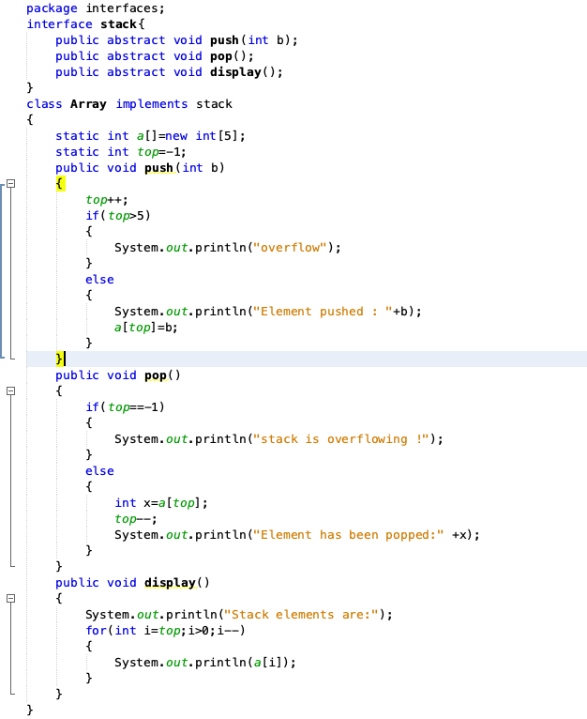

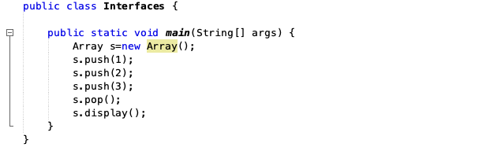

Figure 8.1 Represents stack ADT using array

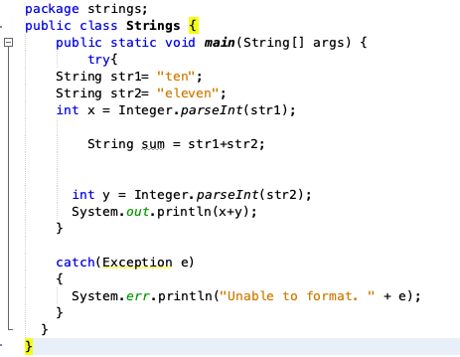

*Figure 8.2* Represents exception handling to input five array elements through command line.

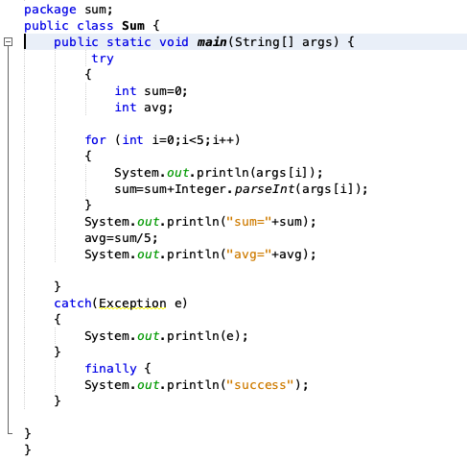

*Figure 8.3* Represents exception handling to throw NumberFormatException using Integer.parseInt

1. Presentation of Results

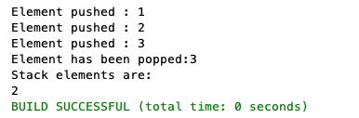

Figure 8.4 output for the stack ADT

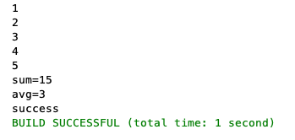

*Figure 8.5* Represents the output without arrayoutofboundsexception

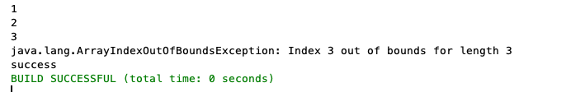

*Figure 8.6* Represents the output with arrayoutofboundsexception

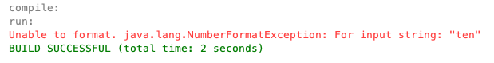

Figure 8.7 Represents the output for numberformatexception

1. Conclusions

If a request for a negative or an index equal. To size of an array is made then the java throws a array index out of bounds.

Number format exception usually occurs when you try to do something like convert a string to a numeric value.

1. Limitations of Experiments and Results

The array index out of bounds exception is a runtime exception thrown only at a runtime.

The complier doesn’t check for this error during the compilation of a program.